**5. WAVE SHAPING CIRCUIT USING OPERATIONAL AMPLIFIER - CLIPPER AND CLAMPER**

* 1. **OBJECTIVE**

a. To study the operation of wave shaping circuits (clipper and clamper) using op-amps, such as half wave rectifier and full wave rectifier

### HARDWARE REQUIRED

|  |  |  |  |
| --- | --- | --- | --- |
| 1 | IC 741 | Refer data sheet in appendix | 1 |
| 2 | Cathode Ray Oscilloscope | (0 – 20MHz) 1 | 1 |
| 3 | Resistors | 2.2 K Ω, 4.7K,  10KPOT | 3 |
| 4 | Semiconductor(Diode) | 1N4002 | 2 |
| 5 | Dual Regulated power supply | (0 -30V), 1A | 1 |
| 6 | Function Generator | (0-2) MHz | 1 |
| 7 | ASLK PRO Kit | Refer data sheet in appendix | 1 |

* + 1. **THEORY**

ACTIVE CLIPPER

Clipper is a circuit that is used to clip off (remove) a certain portion of the input signal to obtain a desired output wave shape. In op-amp clipper circuits, a rectified diode ma be used to clip off certain parts of the input signal. Fig. 2-2-4 (a) shows an active positive clipper, a circuit that removes positive parts of the input signal. The clipping level is determined by the reference voltage

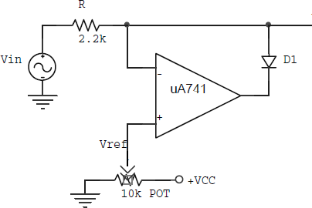

***Fig 5(a)*** *Active clipper*

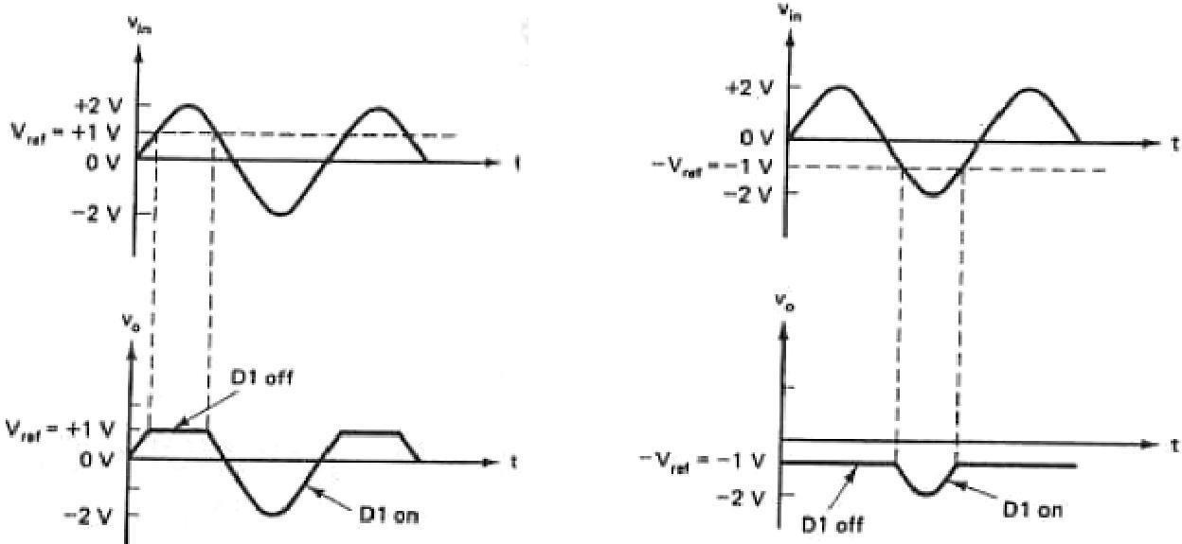

(b) (c)

***Fig 4*** *(b) input & output waveforms with +Vref, (c) input & output waveforms with -Vref*

With the wiper all the way to the left, Vref is o and the non-inverting input is grounded. When Vin goes positive, the error voltage drives the op-amp output negative and turns on the diode. This means the final output VO is 0 (same as Vref) for any positive value of Vin.

When Vin goes negative, the op-amp output is positive, which turns off the diode

and opens the loop. When this happens, the final output VO is free to follow the negative half cycle of the input voltage. This is why the negative half cycle appears at the output. To change the clipping level, all we do is adjust Vref as needed.

### Active clamper

In clamper circuits, a predetermined dc level is added to the input voltage. In other words, the output is clamped to a desired dc level. If the clamped dc level is positive, the clamper is called a *positive clamper.* On the other hand, if the clamped dc level is negative, it is called a *negative clamper.* The other equivalent terms for clamper are *dc inserter or dc restorer.*

A clamper circuit with a variable dc level is shown in fig (a). Here the input wave form is clamped at +Vref and hence the circuit is called a positive clamper.

1uF C1

Vo

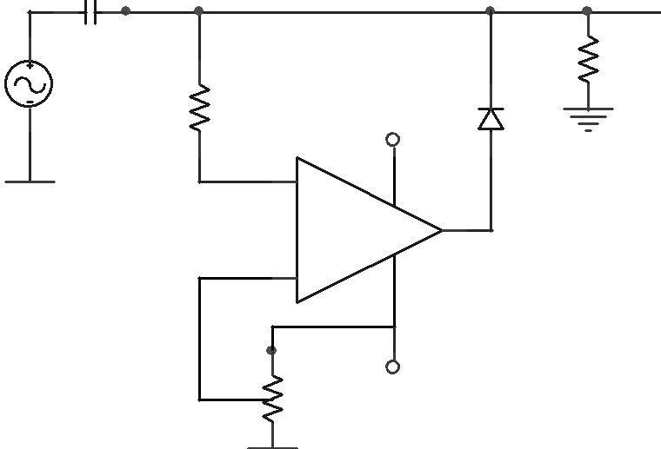

- +

Vp

-

+

+VCC

RL

Vin 1k

***R=4.7k, Rp=10k***

***Fig 5 (b)*** *Peak clamper circuit*

The output voltage of the clamper is a net result of ac and dc input voltages applied to the inverting and non-inverting input terminals respectively. Therefore, to understand the circuit

Operation, each input must be considered separately. First, consider Vref at the non-inverting

Input. Since this voltage is positive, is +Vo is positive, which forward biases diode D1. This closes the feedback loop and the op-amp operates as a voltage follower. This is possible because C1 is an open circuit for dc voltage. Therefore Vo = Vref. As for as voltage Vin at the

Inverting input is concerned during its negative half-cycle D1 conducts, charging C1 to the negative peak value of the VP. However, during the positive half-cycle of VIN diode D1 is reverse biased and hence the voltage VP across the capacitor acquired during the negative half-cycle is retained. Since this voltage VP is in series with the positive peak voltage VP, the output peak voltage VO=2VP. Thus the net output is Vref +VP, so the negative peak of 2VP is at Vref. For precision clamping C1Rd<<T/2, where Rd is the forward resistance of the diode

D1 (100Ω typically) and T is the time period of VIN. The input and output wave forms are shown in figure.

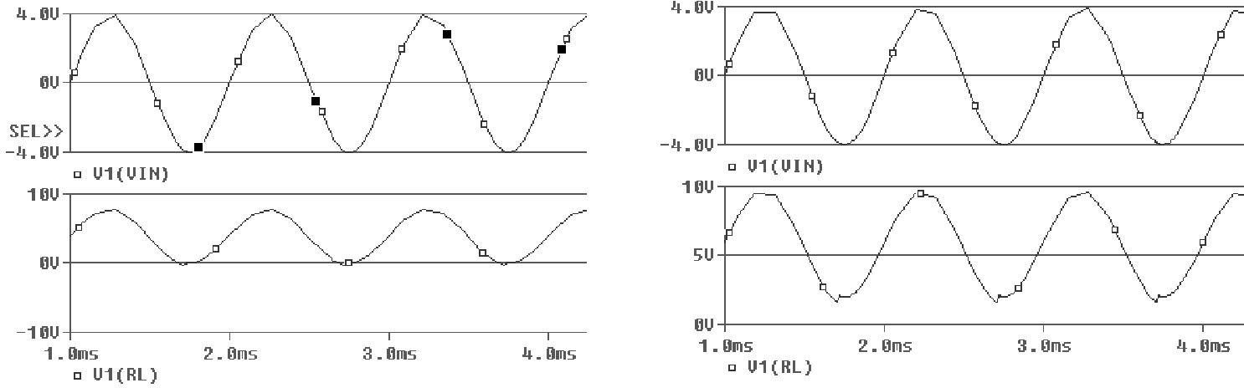

* + 1. 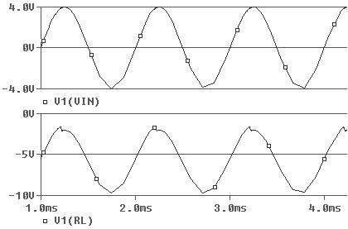*(ii)*

***(iii)***

***Fig 5(c)*** *Input and output waveforms (i) with Vref=0V, (ii) with +Vref, (iii) with -Vref*

Resistor R is used to protect the op-amp against excessive discharge currents from capacitor C1 especially when the dc supply voltages are switched off. Negative clamping at a negative voltage is accomplished by reversing diode D1 and using the negative reference voltage – Vref.

### Experiment

1. Connect the components/equipment R=2.2KΩ use IN4002 diode. Sinusoidal input amplitude 3v and frequency 1Khz.as shown in the circuit diagram.
2. Switch ON the power supply.
3. Apply 1V dc voltage as reference voltage at the inverting terminal of IC741.
4. Connect the channel-1 of CRO at the input terminals and channel-2 of CRO at the output terminals.
5. Observe the input sinusoidal signal at channel-1 and the corresponding output square wave at channel-2 of CRO. Note down their amplitude and time period.
6. Overlap both the input and output waves and note down voltages at positions on sine wave where the output changes its state. These voltages denote the Reference voltage.
7. Plot the output wave form.

### Active clamper

* 1. Connect the components/equipment clamping level at zero as shown in fig.5 (a). Note that Vref = 0V. Consider C1 = 0.1µF, R = 4.7 KΩ and RL = 10 KΩ . Use 1N4002 diode. Feed 5VPP, 10 KHz sinusoidal inputs.
  2. Switch ON the power supply.
  3. Apply 1V dc voltage as reference voltage at the inverting terminal of IC741.
  4. Connect the channel-1 of CRO at the input terminals and channel-2 of CRO at the output terminals.
  5. Observe the input sinusoidal signal at channel-1 and the corresponding output square wave at channel-2 of CRO. Note down their amplitude and time period.
  6. Overlap both the input and output waves and note down voltages at positions on sine wave where the output changes its state. These voltages denote the Reference voltage.
  7. Plot the output wave form.

### Observation Clipper

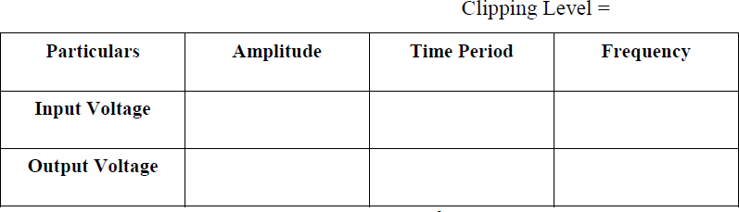

**Observation Clamper**

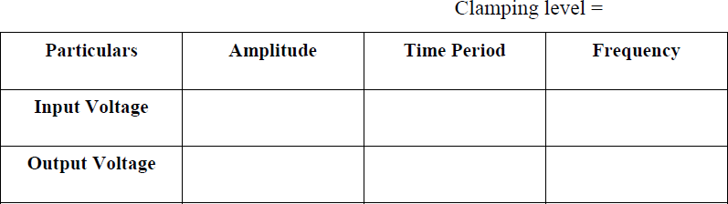

**Prelab**

1. Find the output waveform for when Vin < Vref

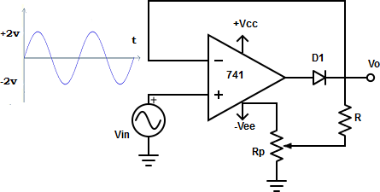

1. Determine the output waveform for a clamper with input =4Vp sine wave and Vref=1V.
2. Why clamper is called a DC restorer?
3. What are the applications of clippers and clampers?
4. What is the factor which determines clipping level in a clipper?

### Postlab

### For a given sinusoidal input voltage, the voltage waveform at point P of the clamper circuit shown in figure will be

### 

### A) B)

### C) D)

1. Compare clipper with clamping circuit
2. Which elements are used in linear and non-linear wave shaping circuits?
3. Draw the output waveform for the following circuit

****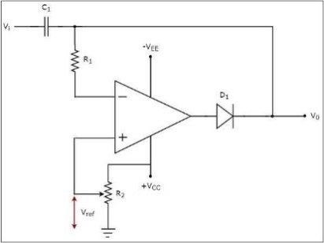

1. Sketch the negative clamper using opamp

### Result